Zumi Lesson December 29th

Intro to **creating** a route function (Fx that makes instructions for Zumi to navigate the course)

**Recap of last lesson**

Last lesson we took a test on Classes and Dictionaries. Programming wise, I introduced a new function called “TravelP2P” which executes a route aka drives Zumi based on a series of instructions.

**Introduction to today’s lesson**

In order to understand todays lesson, we need establish a few things to help us create a route.

1. We’ll refer to Zumi moving in map in terms of compass directions ( North, South, East, West). When Zumi is originally at the start, we will say, Zumi is pointing East.

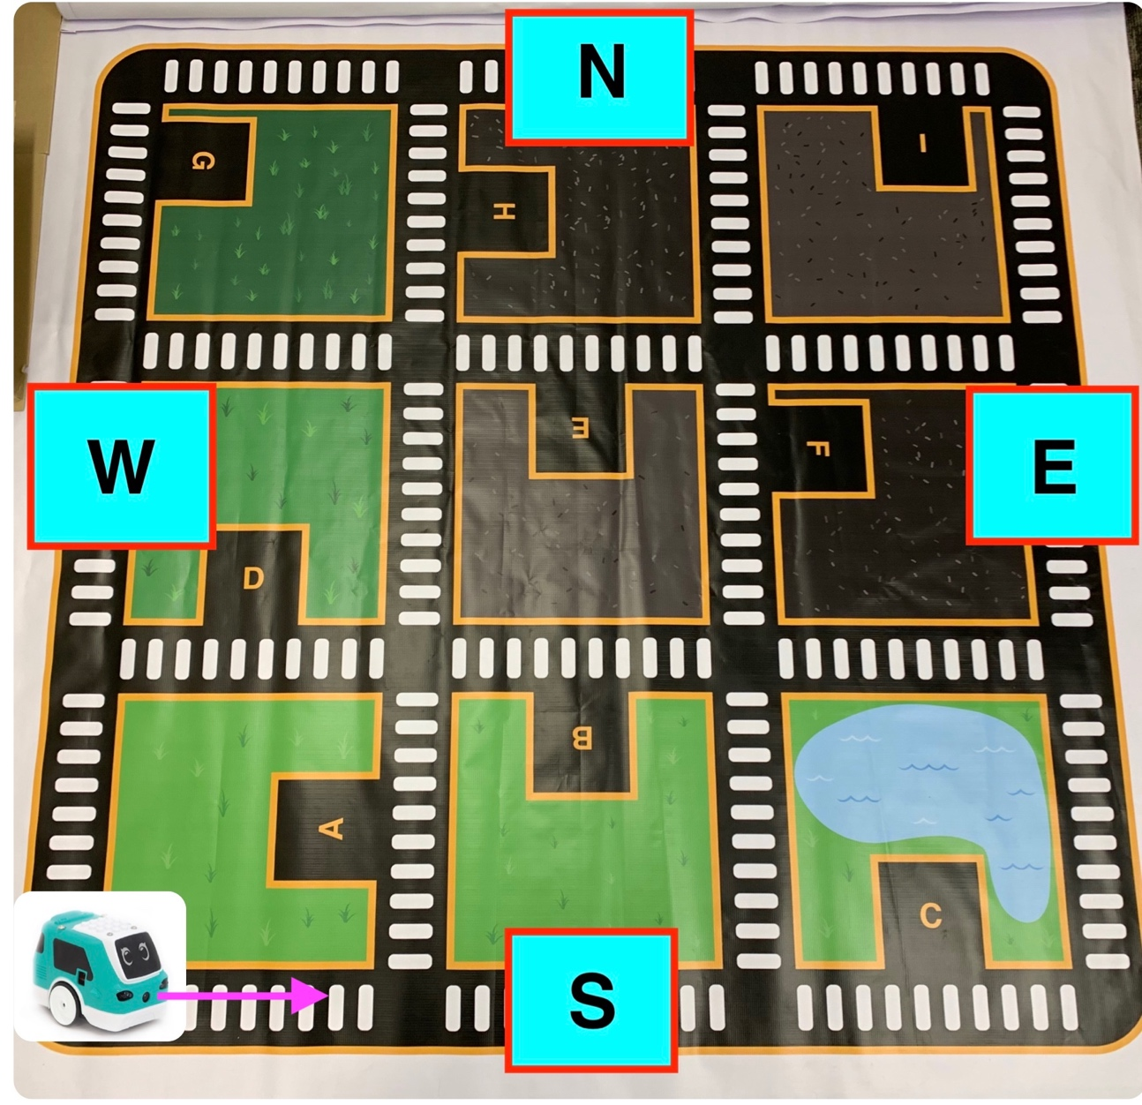

The pink arrow is pointing to the right which is why we say Zumi is pointed to the East

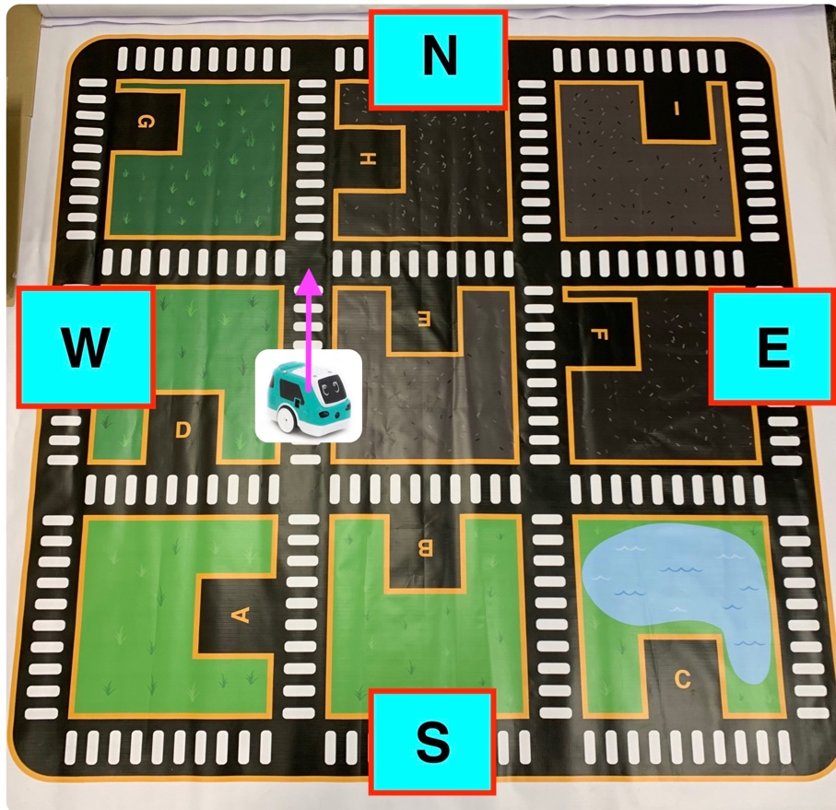

In this diagram we would describe Zumi moving **North**

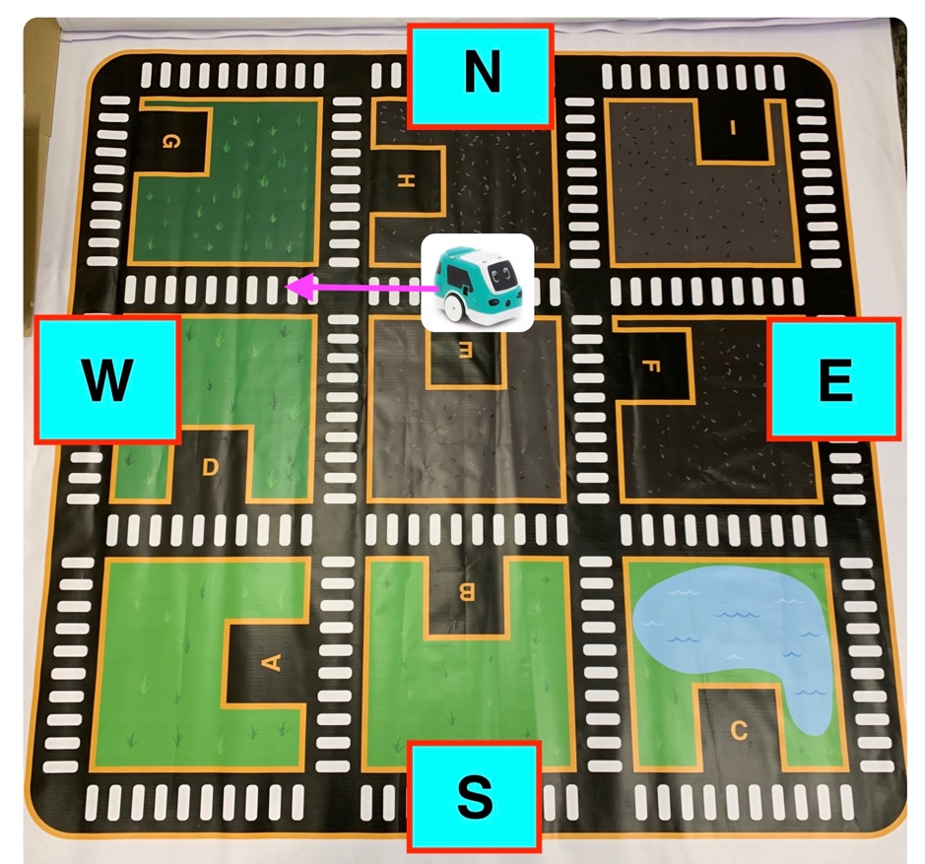

In this diagram we would describe Zumi moving **West**

Why do we do this ? because right and left is too vague. We could say Zumi is moving right if I were standing at the if standing at the east position in the top diagram. Also +x and -x would be confusing

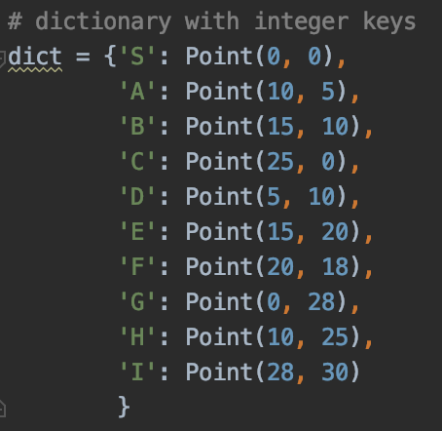

2.) We’ll refer to the competition field letters in terms of coordinates based on how many white spaces they are from the start in the bottom left corner.

Start == S (0,0) == bottom left corner

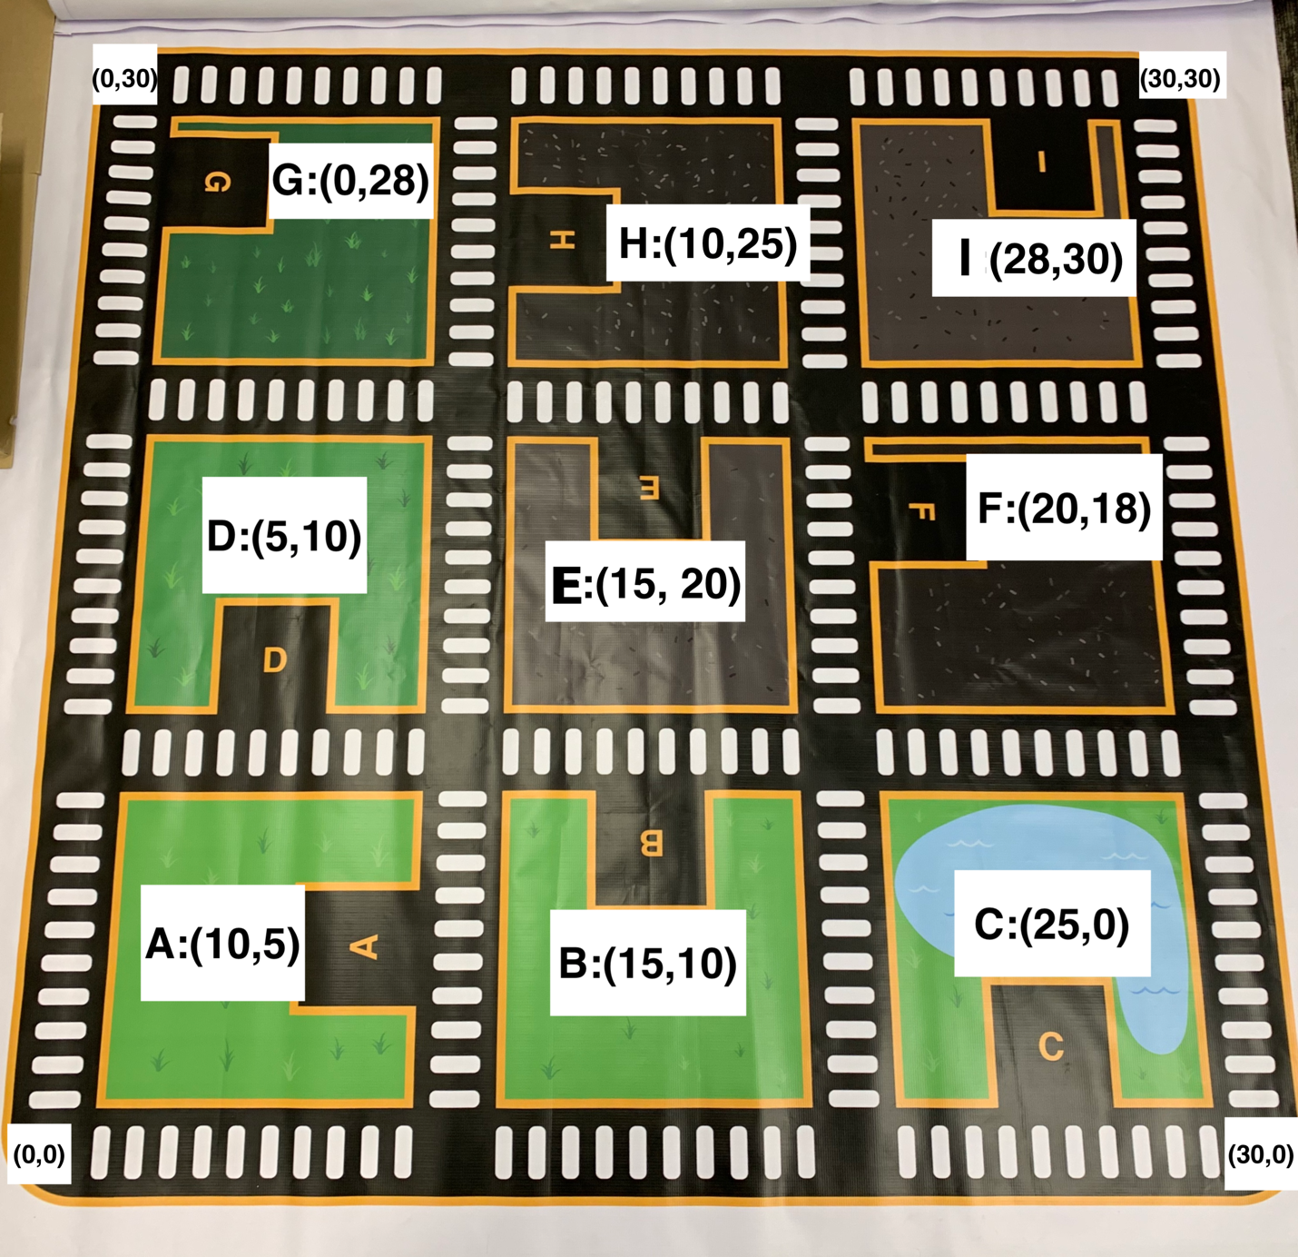

**Route ( S -> B )**

Zumi is Pointed East

Stride 0:

Dir = x

Dist = 10

NESW = E

Stride 1:

Left

Stride 2:

Dir = y

Dist = 10

NESW = N

Stride 3:

Right

Stride 4:

Dir = x

Dist = 5

NESW = E

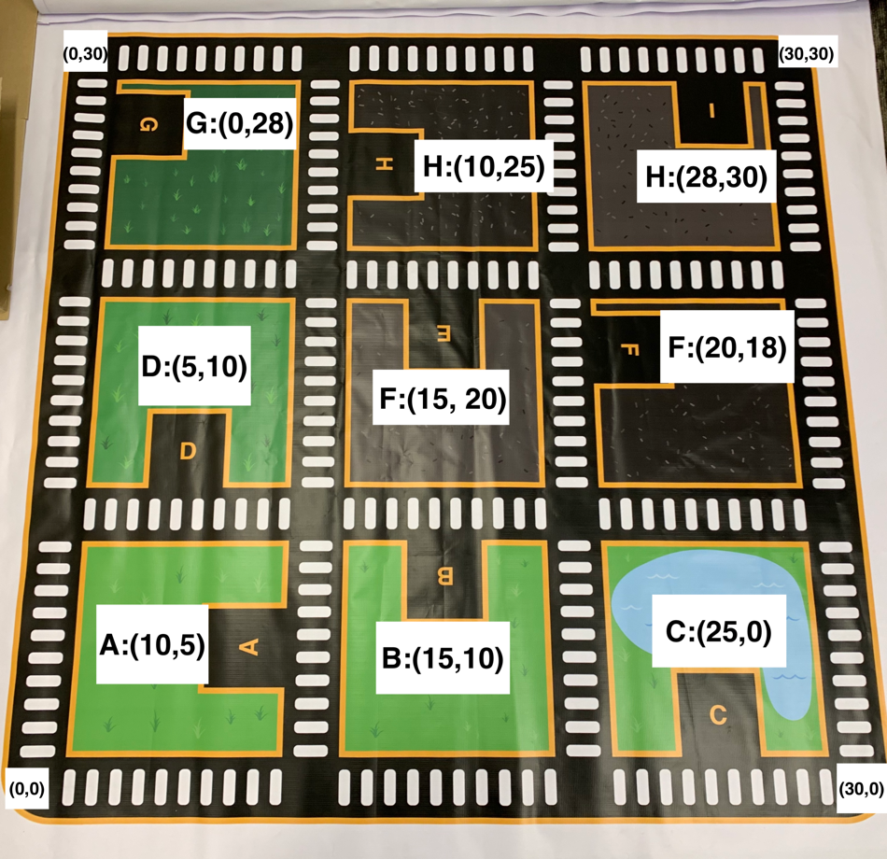

3.) Defining what a stride is. A stride is a movement Zumi undergoes whether it be moving a full block, half block, quarter block, or going through an intersection.



**Route ( I -> E )**

Zumi is pointed West

Stride 0:

Dir = x

Dist = 8

NESW = W

Stride 1:

Left

Stride 2:

Dir = y

Dist = 10

NESW = S

Stride 3:

Right

Stride 4:

Dir = x

Dist = 5

NESW = W

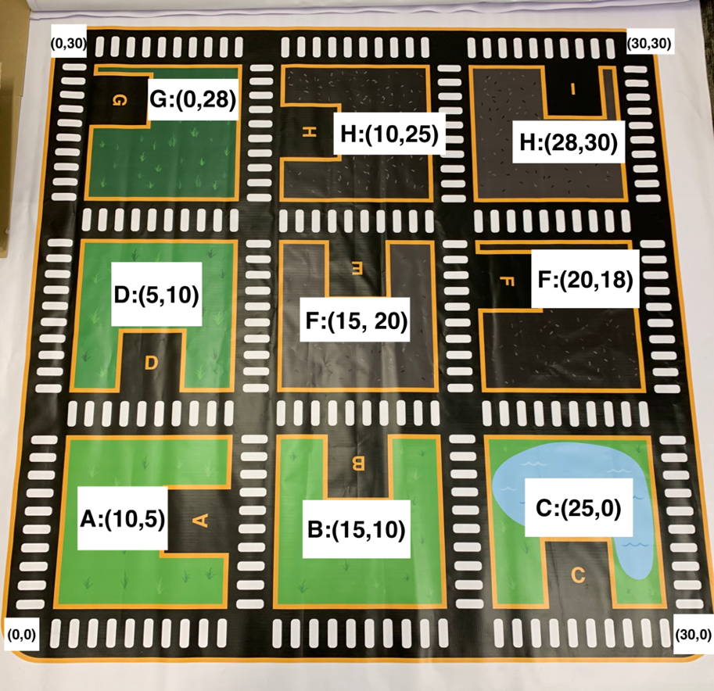

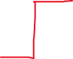



Stride __:

Dir = x or y

Dist = 1-10

NESW = N or S or E or W

Practice with creating a route using the stride method.



**Today’s Lesson:**

So far, we’ve written a function : **getTimeForTravel, gridDistToInches, getCoordinates, and dest2Dest**. Those functions allow Zumi to travel a certain distance based on input of grid spaces. We also have a way of looking up our coordinates.

Our program will work in this fashion:

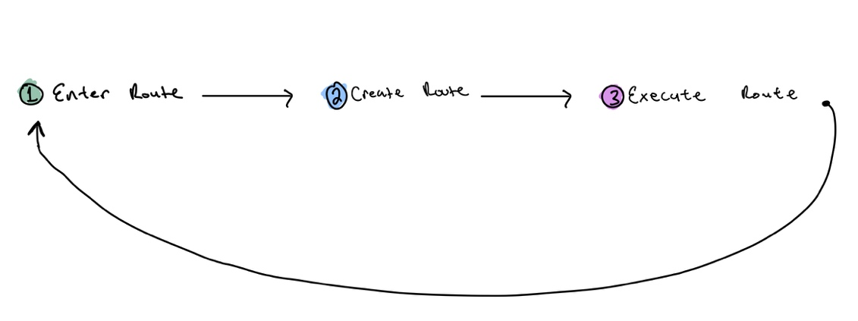

We want to think of creating a route and executing a route as two separate processes.

In creating a route, we make instructions that are not specific to how Zumi moves, rather a set of instructions that humans can understand.

In executing a route, we want to translate those instructions Zumi can understand. For example:

Create Route Execute Route

Dir = x

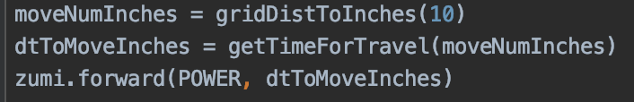

Dist = 10

NESW = E

As of today, we are done with step 1 “Enter Route” and we’ve started step 3 “Execute Route”. Today we will work on step 2 “Create Route”

Activities for the day:

1. create the stride class
2. Talk about the information we need to know in order to create a route
3. Look over the pseudo code
4. Start to write the function create route

Talk about the information we need to know in order to create a route ?

1.)Where Zumi is. how would we do this ?

Turns out there is only 5 pieces of information we need to know in order to move zumi from point to point at any given location

1.) know the position we are heading in

2.) distance we have to travel in the x direction

3.) distance we have to travel in the y direction

4.) current coordinate of the x

5.) current coordinate of the y

Write the pseudo code for the create route function